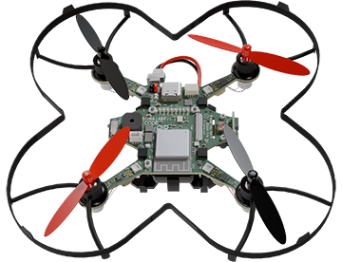

|  |  |
| --- | --- |
| **CodeAIR Mission 2 Assignment** | **Name:** |
| **Pre-Mission Preparation** | |
| What are your goals for this course? What do you hope to be able to do by the end of the missions? |  |
| What are some reasons you should learn Python coding with a drone? |  |
| **Mission 2 Checks** | |
| Objective #1  What A black and white symbol  Description automatically generatedtool did you click on?  What did you learn about the tool? |  |
|  |
| Objective #2  Zoom in before clicking on the bolts so you can easily locate the CPU, USB port and power switch.  What are some suggestions for keeping the CodeAIR safe? |  |
| Objective #3  What are some capabilities of the CPU?  What are some of CodeAIR’s onboard peripherals? |  |
|  |
| Objective #4  What are some facts about CodeAIR’s battery? |  |
| Objective #5  What did you learn about connecting CodeAIR to the computer with a USB cable? |  |
| Objective #6  What are some troubleshooting connections suggestions? |  |
| Objective #7  Where are code files saved? |  |
| Objective #8  What is the purpose of CodeTrek?  What is the purpose of a comment?  What is the purpose of **#TODO** |  |
|  |
|  |
| Objective #9  What are two rules to remember when typing Python code? |  |
| Objective #10  Click on the tool for BYTE LEDs. What are some things you learned about LEDs?  In the code: **leds.set(0, 50)**  The 0 is _____ and the 50 is ______ |  |
|  |
| **Post-Mission Reflection** | |
| What are three things you remember the most about this mission: |  |